Methodology

Notation table
set notation | set describe | index notation
$$W$$ | integer number | $$z$$
 | order or recursion | $$s$$
 | threshold | $$τ$$
 | residual / error | $$ε$$
 | generic coefficient | $$α$$
 | probability | $$p$$
 | Standard deviation | $$σ$$
 | Mean | $$μ$$
$$X$$ | Training data | $$x$$
$$n$$ | data input features | $$a,b$$
$$m$$ | data target features
$$N$$ | data sample size | $$j$$
$$\tilde{N}$$ | hidden neurons size | $$i$$
$$SN$$ | solution size | $$h,q$$
$$L$$ | trial limit
$$MI$$ | max iteration
$$D$$ | solution dimension | $$k$$
$$K$$ | cross validation fold | $$f$$
$$R$$ | Random state seed | $$r$$
$$F$$ | factors
$$G$$ | total sample to evaluate through factor $F$ | $$g$$

Data Handling

Data Recovery
The gallstone dataset is categorized into four parts: demographic data, bioelectrical impedance analysis (BIA) data, laboratory blood test data and categorical comorbidity data. The demographic data and categorical comorbidity data were considered as ground truth and not subjected for further modification. Even though laboratory blood test data exhibited extreme distributions, the data were being retained without modification because the blood test factors are highly dependent on the individual underlying health conditions.
In contrast, BIA were processed using a logical flow constraint, where BMI, TBW $\left(Water\right)$ , TFC $\left(Fat\right)$ and TBP $\left(Protein\right)$ and their relative variables are the main body of the consistency evaluation. For a feature $X_{a}$ of a sample $j$ , it was evaluated on whether that its observed value $x_{j}^{(a)}$ is consistent with its computed value over multiple interdependent physiological relationships ${\hat{x}}_{j}^{(a)}$ . The inconsistency value $ε_{j}^{(a)}$ is calculated by:
$$ε_{j}^{(a)}=x_{j}^{(a)}-{\hat{x}}_{j}^{(a)}$$
The data in a feature $X_{a}$ were evaluated based on a robust statistical limit $τ_{a}$ , which was calculated based on the reference variables ${Ref}_{a}$ such as TBW, TFC and TBP by:
$${MAD}_{a}^{normal}=1.4826×{median}_{j}\left(\left|ε_{j}^{(a)}-{median}_{j}\left(ε_{j}^{(a)}\right)\right|\right)$$
$$τ_{a}^{stat}=α_{MAD}×{MAD}_{a}^{normal}$$
$$τ_{a}^{floor}=\left\{\begin{aligned}0.015×\left|{median}_{j}\left(x_{j}^{(a)}\right)\right|, {Ref}_{a}≠∅ \\ 0.5 ,{Ref}_{a}=∅\end{aligned}\right.$$
$$τ_{a}=max\left(τ_{a}^{stat},τ_{a}^{floor}\right)$$
If a set of relational constraints having multiple inconsistencies exceed the robust statistical limits but a specific inconsistency remained in bound, the certain constraint was considered as relatively correct. Hence, the only excluded variable in this constraint was considered as the residual reason and was fixed based on the certain constraint. For those exhibiting global inconsistencies, the samples were dropped from dataset as there was not robust references.
The recovered data samples were validated against their respective references such as TBW, TBC and TBP. While TBW, TFC and TBP were validated by referred to weight by the four-compartment (4C) mode constraint:
$${Weight}_{j} = {Water}_{j} + {Fat}_{j} + {Protein}_{j} + ε_{j}^{4C}$$
where $ε_{j}^{4C}=α_{4C}×{Weight}_{j}$ , which represented the other trace elements in the human body. $α_{4C}$ is its ratio to body mass coefficient where: $α_{4C}= {median}_{j}(1 - \frac{{Water}_{j} + {Fat}_{j} + {Protein}_{j}}{{Weight}_{j}})$

Data Splitting and Preprocessing
To robustly evaluate the generalization ability of the models, the data was partitioned using a 5-fold cross validation with internal validation split. Within each fold, 20% of the data was isolated as an unseen testing dataset, while the remaining 80% data was split again with an 80:20 ratio into a 64% training dataset and a 16% validation dataset. As different models having varying sensitivity on data scale, scaling strategies were tailored to accommodate the specific models. Unlike using raw data for scale-invariant models, a Min-Max Scaler was used for other models to explicitly constrain the data to range [0,1]:
$$x_{j,scaled}^{(a)}= \frac{x_{j}^{(a)}-x_{min}^{(a)}}{x_{max}^{(a)}-x_{min}^{(a)}}$$
As mentioned before, laboratory blood test data exhibit extreme distributions. Before the data normalization, a logarithmic function, $log\left(1+x\right)$ was applied to laboratory blood test data to smooth the highly right skewed distribution, preventing the over compression influence of extreme value to low value.
After that, data normalization was executed dynamically to prevent data leakage. The scaling parameters were strictly computed on the active training set and applied only to the corresponding validation set or testing set, including the internal cross validation of any subset. During the final evaluation phase, the models’ performances were evaluated based on the 5 outer folds. The models were trained on the 80% dataset (merging of training and validation dataset) and then tested on the 20% unseen testing set, where the scaler was fitted on the 80% dataset and used to transform the 20% testing set.

Risk-Averse Evaluation
In a machine learning study, multiple factors are generally interdependent. During the evaluation of some specific factors, other factors are generally required to be controlled or isolated. To mitigate judgemental noise induced by these factors and obtain robust estimates during model tuning, the evaluation of the specific model architecture is conducted under a risk-averse strategy. Specifically, a hierarchical risk-averse scheme is used to evaluate the specific factor by its predefined blocking factors. As example, the performance of the model with a specific random seed can be evaluated based on the blocking factor, $K$ folds performance, vice versa.
To evaluate the first-level factor, the risk-adjusted score ${ LCB}_{F}^{\left(1\right)}$ which only evaluates its individual stability based on its variance is applied. Given a target $t$ with $F$ other blocking factors to be evaluated, the risk-adjusted score${ LCB}_{F}^{\left(1\right)}$ after isolating factor $F$ is calculated as:
$$μ_{F}= \frac{1}{W}\sum_{z=1}^{W}{t_{z}^{(F)}}$$
$$σ_{F}=\sqrt{\frac{\sum_{z=1}^{W}{{\left(t_{z}^{(F)}-μ_{F}\right)}^{2}}}{W-1}}$$
$${LCB}_{F}^{\left(1\right)}=μ_{F} - \left(α_{1}×σ_{F}\right)$$
During further aggregation, the trustworthiness of the distribution at the previous level is evaluated based on the resulting $LCB$ values. Assuming a ${\left(s-1\right)}^{th}$ order of recursion, where a total $G$ samples of $LCB_{F}^{\left(s-1\right)}$ have been obtained, the ${LCB}_{F}^{\left(s\right)}$ is calculated based on the samples ${\left\{{LCB}_{Fg}^{\left(s-1\right)}\right\}}_{g=1}^{G}$ :
$$μ_{F}^{\left(s-1\right)}=\frac{1}{G}\sum_{g=1}^{G}{LCB_{Fg}^{\left(s-1\right)}}$$
$$σ_{F}^{\left(s-1\right)}=\sqrt{\frac{\sum_{g=1}^{G}{{\left(LCB_{Fg}^{\left(s-1\right)}-μ_{F}^{\left(s-1\right)}\right)}^{2}}}{G-1}}$$
$$LCB_{F}^{\left(s\right)}=μ_{F}^{\left(s-1\right)}-α_{s}⋅\frac{σ_{F}^{\left(s-1\right)}}{\sqrt{G}}$$

Experiment Set Up

Models Optimizing
The study was designed to evaluate two main models’ performances: stability and generalization. During the tracing and parameter tuning phase, a total of 30 random seeds were fixed (random seeds 131-160 on this study), and a 5-fold train-validation set was employed. For each architecture, a total 150 records were collected for evaluation and decision-making. As the main optimization of ELM focus on reducing the impact of random initialization, the evaluation of each architecture is based on the risk-averse concept.
The process first retrieved the performance of a single seed $r$ over the 5-fold data, represented as${ LCB}_{r}^{\left(1\right)}$, and used it to evaluate the different architectures among the same seeds, yielding ${ LCB}_{Architecture}^{\left(2\right)}$ . The optimal parameter of the hidden nodes sizes and lambda value for models were considered and decided by maximizing the ${ LCB}_{Architecture}^{\left(2\right)}$ .
There are multiple factors during metaheuristic parameter tuning to be considered. Among multiple identical architecture models, different parameters setups were evaluated based on ${ LCB}_{F}^{\left(3\right)}$ , which was derived from ${ LCB}_{Architecture}^{\left(2\right)}$. In this study, the first factors evaluated and fixed were the internal algorithm of ABC, followed by the ratio between the population $\left(SN\right)$ and trial limit $\left(L\right)$, and then finally the population and maximum iterations $\left(MI\right)$. Notably that in this study, the setup of risk averse are $1≤s≤3$ and $α_{s}=\left\{\begin{aligned}1 , s=1 \\ 2.58,s>1\end{aligned}\right.$ to enhance high confidence while prevent information loss by over penalizing.

Models Performances Testing
During the final testing of models’ performances, across the 5 outer folds 80/20 data, total 50 random seeds were used to account the high variance caused by ELM random initialization. Testing seeds were sampled through range 0-99999 excluding 131-160 with a master seed of 42, which avoid the potential bias of the testing results caused by seeds overlapping. To ensure a fair comparison, all models include in the testing phase will apply the same 50 seeds regardless the model affected by seeds or not.

Statistical Test
To obtain a boarder and more rigorous perspective of the model performance evaluation, the comparisons of models were not evaluated on the average score only, statistical tests such as Wilcoxon signed-rank test and paired t-test were included. Holm-Bonferroni Correction was implied for them to mitigate the false positive p-value. Bayesian analysis was additionally employed to quantify the exact probability of model superiority.

Wilcoxon Signed-Rank Test
The model stability was evaluated using the results ${ LCB}_{r}^{\left(1\right)}$ from the 5-fold cross-validation for each individual seed $r$ with Wilcoxon signed-rank test. This test was suitable for stability inspection because the large number of random seeds met the sample size requirement, and the variance across seeds cannot be assumed be following normal distribution. As the ELM initialization was highly variance depend on the initialize seeds, the Wilcoxon signed-rank test was primarily used to evaluate whether the optimization process had effectively stabilized the model. To obtain a fair perspective on baseline comparison also, the comparisons were conducted across other models excluding the convex optimal models.

Paired t-test
In contrast, the generalization ability of the models was evaluated under the averaging results of all seeds over each fold (to neutralize the initialization variance). As the averaging process collapsed the records into 5 remaining aggregate results, the sample size became unsuited for Wilcoxon signed-pair test. Considered that the cross-validation results came from each fold of data overlapping each other, the performance of models should approximate a normal distribution. The paired t-test was utilized for the evaluation of the robustness of models across varying data partitions.

Bayesian Evaluation
While the paired Wilcoxon test and paired t-test provided statistical significance p-value, they didn’t quantify the magnitude of results difference. A Bayesian evaluation of posterior probability was conducted to estimate the overall performance of the proposed model across several representative models, which provides the direct probabilistic insights of the percentage in three dimensions: outperforms, performing worse or practically equivalent.

Statistical Test Result Notation
Statistical significance was denoted using asterisks and +/- notation: * for p<0.05, ** for p<0.01, and *** for p<0.001, a '+' indicates that the proposed model significantly outperforms while '-’ indicates the opposite. The result signs were placed above the comparatively weaker models where orange symbols represent the Wilcoxon signed-rank test, while blue symbols represent the paired t-test. During the Bayesian evaluation, green and red colour represents the probability of proposed model will win or lose respectively, while grey colour represents the probability that both models located in Region of Practical Equivalent (ROPE). Besides that, the percentage located on each colour represents exact percentage of the probability for the case respectively.

Evaluation Metrics
The metrics applied for the evaluation of models included Accuracy, F-Score and Matthews Correlation Coefficient (MCC). These classification scores are calculated based on 4 basic confusion matrix categories:
$$TP=True Positive , TN=True Negative \\ FP=False Positive , FN=False Negative$$
where Positive and Negative represent the prediction values while True and False denotes whether the prediction matches the actual ground truth.
The Accuracy is the implementation of evaluating overall correctness of the model's predictions.
$$Accuracy=\frac{TP+TN}{TP+TN+FP+FN}$$
While F_{β}-Score is a composite metric which focuses on the TP values. The coefficient $β$ defined by the relative importance of recall to precision. For example, F₁-Score is considering Precision is as important as Recall, while F₂-Score considers Recall twice as important as Precision.
$$F_{β}=(1+β^{2})∙\frac{Precision∙Recall}{β^{2}∙Precision+Recall}$$
where Precision evaluates the exactness of positive predictions while Recall evaluates the ability of finding all positive cases: $Precision= \frac{TP}{TP+FP}$ and $Recall= \frac{TP}{TP+FN}$
Matthews Correlation Coefficient (MCC) is a comprehensive evaluation metric that incorporates all four categories of the confusion matrix. Unlike Accuracy, which will loss information under class imbalance situation, while F_{β}-Score ignoring the True Negative case, MCC equally considering all four quadrants, ensuring a more robust evaluation of models’ classification ability.
$$MCC= \frac{TP∙TN-FP∙FN }{\sqrt{\left(TP+FP\right)∙(TP+FN)∙(TN+FP)∙(TN+FN)}}$$

Designs and Models

Extreme Learning Machine (ELM)
ELM is a Single-Layer Feedforward Neural Network (SLFN) proposed by Huang et al. in 2006. ELM is generally considered faster because it does not require complicated iterative tuning of parameters like traditional gradient descent-based feedforward neural networks. The theory of ELM indicates that the hidden layer does not need to be tuned, where input weights and hidden layer biases can be randomly assigned and fixed. Once these parameters are fixed and utilized with an infinitely differentiable (or merely piecewise continuous) activation function, the hidden layer outputs become a constant matrix. Hence, the relationship between the hidden layer and the target values can be modelled as a linear system, allowing the output weights to be analytically determined through the Moore-Penrose pseudo-inverse.
For a standard SLFN, given $N$ arbitrary distinct training samples $\left(x_{j},t_{j}\right)$, where $x_{j}={\left[x_{j1},x_{j2},…,x_{jn}\right]}^{T}∈R^{n}$ and $t_{j}={\left[t_{j1},t_{j2},…,t_{jm}\right]}^{T}∈R^{m}$, with $\tilde{N}$ hidden nodes and activation function $g(x)$, it can mathematically modelled as:
$$\sum_{i=1}^{\tilde{N}}{β_{i}g_{i}\left(x_{j}\right)}=\sum_{i=1}^{\tilde{N}}{β_{i}g\left({w_{i}∙x}_{j}+b_{i}\right)}=o_{j} , j=1,… ,N ,$$
where $w_{i}={\left[w_{i1},w_{i2},…,w_{in}\right]}^{T}$and $β_{i}={\left[β_{i1},β_{i2},…,β_{im}\right]}^{T}$. If an SLFN achieves zero training error, it satisfies the following condition: $\sum_{j=1}^{N}{\left\|o_{j} - t_{j}\right\|}=0$, therefore, there exist $β_{i}$ , $w_{i}$ and $b_{i}$ such that:
$$\sum_{i=1}^{\tilde{N}}{β_{i}g\left({w_{i}∙x}_{j}+b_{i}\right)}=t_{j} , j=1,… ,N .$$
Hence, it can be compactly expressed as: $Hβ=T$ , where
$H\left(w_{1},…,w_{\tilde{N}},b_{1},…,b_{\tilde{N}},x_{1},…,x_{N}\right)={\left[\begin{matrix}g\left({w_{1}∙x}_{1}+b_{1}\right) & ⋯ & g\left({w_{\tilde{N}}∙x}_{1}+b_{\tilde{N}}\right) \\ ⋮ & ⋯ & ⋮ \\ g\left({w_{1}∙x}_{N}+b_{1}\right) & ⋯ & g\left({w_{\tilde{N}}∙x}_{N}+b_{\tilde{N}}\right)\end{matrix}\right]}_{N×\tilde{N}}$,
$β={\left[\begin{matrix}β_{1}^{T} \\ ⋮ \\ β_{\tilde{N}}^{T}\end{matrix}\right]}_{\tilde{N}×m}$and $T={\left[\begin{matrix}t_{1}^{T} \\ ⋮ \\ t_{N}^{T}\end{matrix}\right]}_{N×m}$
According to Huang et al., training an SLFN is simply equivalent to finding the least-squares solution of the linear system $Hβ=T$. As the objective is to minimize the training error, the process can be defined as finding $\hat{β}=arg \min_{β}\left\|Hβ-T\right\|$ . This produces a unique minimum norm least-squares solution of $Hβ=T$ , which is $\hat{β}=H^{†}T$ where $H^{†}$ is the Moore–Penrose generalized inverse of $H$.
Based on ELM, Wanyu Deng et al. proposed Regularized Extreme Learning Machine (RELM) in 2009 to address the overfitting issue. The core idea is minimizing the weighted sum of empirical risk ${\left\|ε\right\|}^{2}$ and structural risk ${\left\|β\right\|}^{2}$ with weight factor $γ$. Additionally, the error variable $ε_{j}$ can be weighted with factors $v_{i}$ to obtain a robust estimate by mitigating outlier interference, extending ${\left\|ε\right\|}^{2}$to ${\left\|Dε\right\|}^{2}$. The proposed RELM model is expressed as:
$$min\frac{1}{2}{\left\|β\right\|}^{2} + \frac{1}{2}γ{\left\|Dε\right\|}^{2}$$
$$s. t. \sum_{i=1}^{\tilde{N}}{β_{i}g\left({w_{i}∙x}_{j}+b_{i}\right)}- t_{j}=ε_{j} , j=1,… ,N$$
where $D=diag(v_{1},v_{2},…,v_{N})$ and $ε=\left[ε_{1},ε_{2},…,ε_{N}\right]$ . The best generalization performance is achieved by balancing the two risks using a Lagrangian approach. The solution of RELM is expressed as:
$$\hat{β}={\left(\frac{I}{γ}+H^{T}D^{2}H\right)}^{†}H^{T}D^{2}T$$
When $D$ is a unit matrix $I$ (non-weighted), $\hat{β}$ simplifies to:
$$\hat{β}={\left(\frac{I}{γ}+H^{T}H\right)}^{†}H^{T}T$$
For the case where $\tilde{N}≫N$, based on push-through property, $\hat{β}$ can be calculated by:
$$\hat{β}={H^{T}\left(HH^{T}+\frac{I}{γ}\right)}^{†}T$$

Notably, there was only a unified programmatic model constructed in this study, which was designed to dynamically perform the standard ELM and RELM architecture based on the input regularization parameter, $λ\left(where λ=\frac{1}{γ} \right)$ value.

Activation Function
The activation function implied for ELM was sigmoid function: $g(x)=\frac{1}{1+e^{x}}$

Artificial Bee Colony Algorithm (ABC)
The Artificial Bee Colony (ABC) algorithm is a swarm intelligence-based metaheuristic that simulates the foraging behaviour of honeybees. The concept of utilizing bee swarms was initially introduced by Karaboga in 2005, while the formal algorithm was proposed by Karaboga and Basturk in 2007. Conceptually, the ABC model is composed of three components: food sources, employed foragers, and unemployed foragers. A food source represents a nectar source, while employed foragers are the bees currently exploiting or associating with a respective food source and sharing the information with the nest. The unemployed foragers consist of two types of bees: onlooker bees, which receive information from employed bees and evaluate the food sources; and scout bees which randomly explore the surroundings for new food sources.
Based on this concept, ABC algorithm was designed around three groups of bees and the food sources. The number of employed bees is equal to both the number of onlooker bees and the number of food sources, while the number of scout bees is initially zero. A food source represents a candidate solution in the search space; an employed bee represents the evaluation and potential replacement of the solution; an onlooker bee represents the evaluation and exploitation of a solution based on the information shared by employed bees; a scout bee is converted from an employed bee or scout bee if its associated solution is unable to improve further and thus randomly explore a new solution. The quality of the solutions is evaluated by a fitness function.
In the ABC algorithm, the basic parameters are defined as follows: Population size $\left(SN\right)$, which is the number of food sources or solutions; Trial limit $\left(L\right)$, which is the mining round, or the maximum number for the neighbourhoods exploitation of a solution before abandonment; and the termination criteria, normally limited by maximum number of iterations $\left(MI\right)$, or a non-improvement iteration count for early stopping architecture. The ABC algorithm’s main steps are shown as follows:
- Initialize the algorithm by randomly generating the solutions
- Evaluate the fitness of the initial solutions
- Repeat the iteration process:
- Employed Bee Phase: Employed bees explore new solutions in the neighbourhood search space of existing solutions, evaluate their fitness and compare with the respectively existing solutions. The existing solutions will be replaced if the new solutions are better. The solution information is then shared with onlooker bees.
- Onlooker Bee Phase: Onlooker bees selectively explore new solutions or exploit the neighbour search space based on the solution information received from employed bees. The higher the fitness of a solution, the higher its probability of selecting for exploitation. Same as the employed bees, a new solution with better fitness will replace the existing solutions.
- Scout Bee Phase: Scout bees will only be triggered when employed bees and onlooker bees are unable to improve the fitness of the solution after exceeding the predefined trial limit $\left(L\right)$. The solution will be exhausted and replaced with a randomly generated new solution, and the scout bee will revert into employed bees to evaluate the solution and share the information instantly.
- If the termination criteria are met, end the process.

Artificial Bee Colony - Extreme Learning Machine (ABC-ELM)
Since the performance of an ELM is highly sensitive to the random initialization of its input weights and hidden biases, optimizing these parameters is crucial. ABC provides a way to improve the performance and optimize the stability of ELM by tuning its input weights and hidden biases. By optimizing the hidden layer mapping space, the subsequent solution for output weights is determined based on a more robust feature representation rather than a potentially degenerate one caused by random initialization.
This hybrid approach is referred to as ABC-ELM. In this study, the core architectural design of the ABC-ELM algorithm was adopted from Abobakr et al. in 2017. ABC-ELM embeds the ELM into ABC algorithm. The input weights and hidden biases are encoded as a candidate solution $S$ for ABC and the evaluation of ELM prediction is encoded as solution fitness to optimize the ELM.
The algorithmic formulation of ABC-ELM is outlined as follows:
A candidate solution $S$ consists of the complete flattened set of input weights $w$ and hidden bias $b$: $S=\left[w_{11},w_{12},…,w_{1\tilde{N}},w_{21},w_{22},…,w_{2\tilde{N}},w_{n1},w_{n2},…,w_{n\tilde{N}},b_{1},b_{2},…,b_{\tilde{N}}\right]$
where $D=\left(n+1\right)×\tilde{N}$ and all $w_{ai}$ and $b_{i}$ are randomly initialized within range $\left[-1,1\right]$.
The primary objective of optimizing the ELM in this study of classification problems is to improve its ability to correctly identify the data patterns and classify them into their respective classes. Hence, the Matthews Correlation Coefficient (MCC) was utilized as the core performance metric. Since the MCC values range between $\left[-1,1\right]$ , the fitness function is mapped into the interval $\left[0,1\right]$ . The fitness ${fit}_{h}$ for a candidate solution $S_{h}$ is mapped by:
$${fit}_{h}=\frac{1+{MCC}_{h}}{2}$$
This ensures a perfectly linear mapping; the strictly non-negative fitness values prevent mathematical or logical errors. For example, negative value for onlooker bees’ selection probability $p_{h}$ and more than hundred change percentage in Algorithm 2 $\left(ChgPerct\right)$ .
${fit}_{h}$ can be reverted to the original ${MCC}_{h}$ value by following equation:
$${MCC}_{h}=\left(2×{fit}_{h}\right) -1$$
Two distinct procedures are utilized to generate neighbouring solutions, denoted as Algorithm 2 and Algorithm 3. Algorithm 2 is inspired by the spatial dispersal concept of the Invasive Weed Optimization (IWO) algorithm, which generates neighbouring solutions by applying a normally distributed random perturbation with a zero mean and an adaptive standard deviation across the search space. Algorithm 3 relies on the standard ABC mutation procedure, which produces neighbouring solutions by evaluating the differential vector between the current solution and another randomly selected solution within the population.
The algorithms utilized are defined as follows:
For a candidate solution $V$ generated from the current solution $S$:
The following is Algorithm 2 formula:
$$V_{hk}=S_{hk}+rand\left(0,σ_{iter}\right)$$
where $h=1,2,… ,SN , k=1,2,… ,D$. $rand$ is a function that returns a normally distributed random value with $μ=0$ and $σ_{iter}={\left(\frac{{iter}_{max}-iter}{{iter}_{max}}\right)}^{nmi}\left(σ_{initial}-σ_{final}\right)+σ_{final}$
The candidate solution $V$ is generated by selectively perturbing a subset of elements in $S$ , rather than modifying the entire solution. The number of mutated dimensions is adaptively adjusted based on the fitness of the solution, where the number is calculated as follows:
$Change=round\left(\frac{D×ChgPerct}{100}\right)$
$ChgPerct=\frac{{fit}_{best}-fit}{{fit}_{best}}\left({Chg}_{max}-{Chg}_{min}\right)+{Chg}_{min}$
where $fit$ is the fitness of $S$ and ${fit}_{best}$ is the highest fitness among whole population. ${Chg}_{max}$ and ${Chg}_{min}$ represent maximum and minimum percentage can be changed in $S$ respectively.
The following is Algorithm 3 formula:
$$V_{hk}=S_{hk}+∅_{hk}\left(S_{hk}-S_{qk}\right)$$
where $h,q∈\left\{1,2,… ,SN\right\},h≠q$and $k=1,2,… ,D$. $∅_{hk}$ is a random number between $\left[-1,1\right]$.
The element $V_{hk}$ is only mutated from $S_{hk}$ if a random generation probability $p_{hk}$ assigned to it exceeds the probability $P_{copy}$ during the iteration $iter$; otherwise, the original value $S_{hk}$ is inherited. The $P_{copy}$ is calculated as follows:
$P_{copy}=\frac{P_{final}-P_{initial}}{{iter}_{max}}\left(iter\right)+P_{initial}$
where ${iter}_{max}$ is the predefined maximum number of iterations. $P_{final}$and $P_{initial}$ are the predefined final and initial probabilities, respectively.
During the onlooker bee phase, solutions are selected probabilistically based on the fitness information shared by the employed bees. The selection probability $p_{h}$ for a specific solution $S_{h}$ is based on its ratio to best fitness, which is calculated as:
$$p_{h}=\left(α_{onlooker}×\frac{{fit}_{h}}{{fit}_{best}}\right)+\left(1-α_{onlooker}\right)$$
It is worth noting that this implementation diverges from the canonical theoretical formulation originally proposed in the foundational ABC literature (https://github.com/artificialbeecolony/Java_ABC.git), where the probability of selection is proportional to the solution's contribution to the total population fitness:
$$p_{h}=\frac{{fit}_{h}}{\sum_{q=1}^{SN}{{fit}_{q}}}$$

Fitness Evaluation Protocol:
The fitness evaluation process for a candidate solution $S_{h} \left({or neighbor solution V}_{h}\right)$ is defined as follows:
- Construct an $ELM$ network with $\tilde{N}$ hidden nodes and activation function $g(x)$.
- Decode the candidate solution $S_{h}$ $\left(or V_{h}\right)$ and assign the values as the network's input weights and hidden biases to ${ELM}_{h}$.
- Analytically compute the output weights using the training data.
- Validate ${ELM}_{h}$ to obtain the fitness score $fit\left(S_{h}\right)$ or $fit\left(V_{h}\right)$ using the predefined fitness function.

The complete ABC-ELM Optimization Process is detailed as follows:
Step 1: Initialization
Initialize the population with $SN$ solutions $S_{hk}, h=1,2,… ,SN , k=1,2,… ,D$
Apply the fitness evaluation protocol to determine $fit\left(S_{h}\right)$ for all solutions
Initialize the abandonment counter ${trial}_{h}=0, h=1,2,… ,SN$
Step 2: Iterative Optimization Loop
Employed Bees Phase:
Produce a neighbouring candidate solution $V_{h}$ from each solution $S_{h}$ using neighbourhoods generation algorithm.
Apply the fitness evaluation protocol for $V_{h}$
If $fit\left(V_{h}\right) >fit\left(S_{h}\right)$ , replace $S_{h}$ with $V_{h}$ and set ${trial}_{h}=0$ . Otherwise, retain $S_{h}$ and increment ${trial}_{h}$ by 1.
Calculate the probability $p_{h}$ for the solution $S_{h}$
Onlooker Bees Phase:
For each onlooker bee, select a solution $S_{h}$ based on $p_{h}$
Produce a neighbouring candidate solution $V_{h}$ from selected solution $S_{h}$ using neighbourhoods generation algorithm.
Apply the fitness evaluation protocol for $V_{h}$
If $fit\left(V_{h}\right) >fit\left(S_{h}\right)$ , replace $S_{h}$ with $V_{h}$ and set ${trial}_{h}=0$ . Otherwise, retain $S_{h}$ and increment ${trial}_{h}$ by 1.
Scout Bees Phase:
Identify if any solution $S_{h}$ exceeds predefined $limit$
Abandon the exhausted solution $S_{h} , {trial}_{h}>limit\left(L\right)$, replace it with a new randomly generated solution.
Apply the fitness evaluation protocol for $S_{h}$ and set ${trial}_{h}$ to zero.
Step 3: Termination
Repeat Step 2 until the termination criteria are met.
End the process and output the best solution found.

ABC-ELM variants

ABC-ELM Cross Validation (ABC ELM CV)
In the standard ABC-ELM architecture, the fitness evaluation relies on comparing a single scalar value. ABC-ELM CV applies internal K-fold cross-validation to mitigate the overfitting caused by a greedy search approach. However, integrating K-fold cross-validation into the evaluation process yields a distribution of validation scores across the distinct folds. To preserve the algorithm's scalar comparison mechanism, these fold results must be aggregated into a single robust metric.
Therefore, the fitness of each candidate solution is evaluated using a risk-averse Lower Confidence Bound (LCB) derived from the standard deviation (STD) of the cross-validation results, which penalizes high-variance solutions that overfit to local optima. This penalized intermediate fitness score ${fit}_{h}^{LCB}$ of candidate solution $S_{h}$ across total $K$ folds conceptually based on ${ LCB}_{F}^{\left(1\right)}$:
$$μ_{h}= \frac{1}{K}\sum_{f=1}^{K}{{fit}_{f}^{(h)}}$$
$$σ_{h}=\sqrt{\frac{\sum_{f=1}^{K}{{\left({fit}_{f}^{(h)}-μ_{h}\right)}^{2}}}{K-1}}$$
$${fit}_{h}^{LCB}=μ_{h}-\left(α_{CV}∙σ_{h}\right)$$
Furthermore, to prevent non-positive fitness values that could destabilize the algorithm, a strict lower bound of 10⁻⁸ is enforced for the final fitness score ${fit}_{h}$ :
$${fit}_{h}=max\left({10}^{-8},{fit}_{h}^{LCB}\right)$$

Besides the ABC ELM CV, two simple methods of ensemble were attempted. The models were design as a child class of ABC ELM CV to inherit the risk-averse fitness solutions.

ABC-ELM Cross Validation Ensemble (ABC ELM CE)
Standard ELM networks are characterized by very fast training and predicting speed, the difference between constructing a single ELM and an ensemble model, which comprises a small number $\left(K\right)$ of distinct ELM models is negligible. Besides that, $K$ ELM models can be efficiently constructed because the ABC-ELM CV with internal K-fold cross-validation already retains the data scalers (normalization parameters) used for the distinct folds within the model architecture.
Therefore, ABC-ELM Cross Validation Ensemble (ABC ELM CE) which follows the same procedure as ABC-ELM CV apart from the construction of the final ELM model is proposed. Unlike ABC-ELM and ABC-ELM CV which fetch the full training data with a single global scaler and then train the final ELM model, ABC-ELM CE utilizes $K$ distinct fold-specific scalers on respective folds dataset to train multiple ELM models. Consequently, $K$ ELM models which share identical input weights and hidden bias (which is the best solution output from ABC) but different output weights were constructed. The final ensemble model composes all these ELM and determines its output for the classification tasks via a majority voting mechanism.

ABC-ELM CV Iteration-Based Ensemble (ABC ELM IE)
While ABC ELM CE applied ensemble based on identical solution but different partitioned of data, the opposite method was considered. Assume that ABC algorithm will explore and exploit multiple solutions across the lifetime, where there has a best solution for any iteration, it provides the chance of ensemble different solutions ELM. With the best solution of each iteration was retained within the model architecture, the same efficiency concept can be applied. During the ABC iteration, assume that a best solution could be the one that reaches the early stopping scheme and it will become the final result. Hence, all non-identical best solutions across iterations were collected.
To avoid producing a homogenization ensemble model, the ensemble will only be constructed with total number of ELM no more than half of solutions size. The first solution was excluded as it was assumed as the non-iterated solution, and the final solution was included undoubtably as it was the ABC final result. The remaining solutions were formed as the candidate solutions and grouped separately based on the max iteration parameter and the best solutions amount. Each solution was selected by choosing the minimum cosine similarity within its group with the nearest solution in existing solutions. This is mainly to mitigate the chosen of slightly different only solutions resulted from exploitation process.

Experiment
The experimental tracing, parameter tuning and testing were all performed on four desktops with the same configuration in parallel: Dell OptiPlex 7490 AIO, Intel(R) Core (TM) i7-10700 CPU @ 2.90GHz (2.90 GHz), 16GB, and a 64-bit Windows 11 Enterprise operating system.
For the ELM, the number of hidden nodes was optimized over the interval $\left[5,120\right]$ with a step size of 5, resulting in an optimal value of 40 nodes. The RELM incorporated an extra regularization parameter, $λ$ . This was conducted via a geometric grid search over a smaller hidden nodes range, crossed with a $λ$ range of $\left[2^{-25},2^{10}\right]$ using a multiplicative step factor of $2^{0.5}$. RELM achieved better performance with only 30 hidden nodes at $λ=2^{-2.5}$.
Once the optimal hidden nodes and $λ$ were confirmed, all subsequent process involving the ELM and RELM were based on these fixed configurations. The following parameter tracing of the ABC algorithm was conducted utilizing the RELM within ABC ELM CV framework.

ABC Tracing

Neighbourhood Algorithms
First, the convergence behaviours of the ABC neighbourhood algorithms was evaluated by fixing the ratio between $SN$ and $L , where L=\frac{SN}{2}$ across eight distinct configurations: $\left(SN,MI\right)∈\left\{\left(10,120\right),\left(10,1000\right),\left(20,250\right),\left(50,150\right),\left(80,120\right),\left(80,250\right),\left(100,120\right),\left(100,250\right)\right\}$. The following figure 1 showed the boxplot of ABC RELM CV models’ ${ LCB}_{Model}^{\left(2\right)}$ across the configurations, comparing four different combinations of Algorithm 2 and Algorithm 3 for the employed bee and onlooker bee. With the following table 1 detailed the mean and standard deviation over eight ${ LCB}_{Model}^{\left(2\right)}$ , with the final ${ LCB}_{Algorithm}^{\left(3\right)}$ for the algorithms’ combination. The figure 2 showed the convergence trace specifically of (80,120) ABC RELM CV.
From figure 1, there was obviously that the combination of employed bees applied algorithm 3 while onlooker bees applied algorithm 2 performed the tightest interquartile range, demonstrating the highest convergence stability. Conversely, the reverse combination performed slightly tighter interquartile range, but wider dispersion of outliers compared to combination of both algorithm 2 who showing a relatively uniform distribution. Besides that, it also resulted the lowest result of median, suggested that the combination of algorithm having a worst performance over four combinations. Finally, combination of both algorithm 3 achieved the highest median while maintaining secondary stability.
The figure 2 showing the representative convergence trends for each combination. The combination of both algorithm 2 convergence into stable in the earliest stage, and the scout bee being triggered increase continuously. In contrast, combination of both algorithm 3 kept fluctuating until the end of the iteration, with scout bee being triggered the most in early stage and reduced gradually. Different from the pure algorithm combinations, the cross combinations showing a stable convergence during the early stages but maintained small fluctuations during the later stages, also performed the peaks of triggering near the middle.
These observations were relatively aligned with the design of the neighbourhood algorithms, where the algorithm 2 mutated itself by normal distribution, resulting in smaller step of self-surrounding mutation. In contrast, algorithm 3 find the neighbourhood by calculating the distance between it and the selected neighbour solution, produce a movement mutation with different distance. These suggested the approaches that algorithm 2 performed more exploitation of the solution while algorithm 3 performed more exploration of the solution.
This also explained why the combinations showed different results. Combination of the same algorithm performed their property twice, resulting in early convergence and non-fully convergence for algorithm 2 and algorithm 3 respectively. For the cross-combination case, employed bees utilized algorithm 3 to explore the surrounding solution while onlooker bees utilized algorithm 2 to perform the exploitation of the selected better solutions performed the best. Conversely, the reverse approach results in exploiting all the solutions, but it worked with exploring based on the selected better solutions, which totally beat the foraging purpose. Therefore, the combination of algorithm 3 for employed bee and algorithm 2 was selected because it showed good convergence and low sensitivity to $SN$ and $MI$ even combination of two algorithm 3 showed higher potential.
Employed Bee | Onlooker Bee | Training${ LCB}_{Model}^{\left(2\right)}$ | Validation ${ LCB}_{Model}^{\left(2\right)}$ | $${ LCB}_{Algorithm}^{\left(3\right)}$$
Algorithm 2 | Algorithm 2 | 0.6463 ± 0.0246 | 0.5360 ± 0.0121 | 0.5047
Algorithm 2 | Algorithm 3 | 0.6462 ± 0.0208 | 0.5333 ± 0.0117 | 0.5032
Algorithm 3 | Algorithm 2 | 0.6467 ± 0.0206 | 0.5324 ± 0.0047 | 0.5202
Algorithm 3 | Algorithm 3 | 0.6494 ± 0.0220 | 0.5360 ± 0.0088 | 0.5133

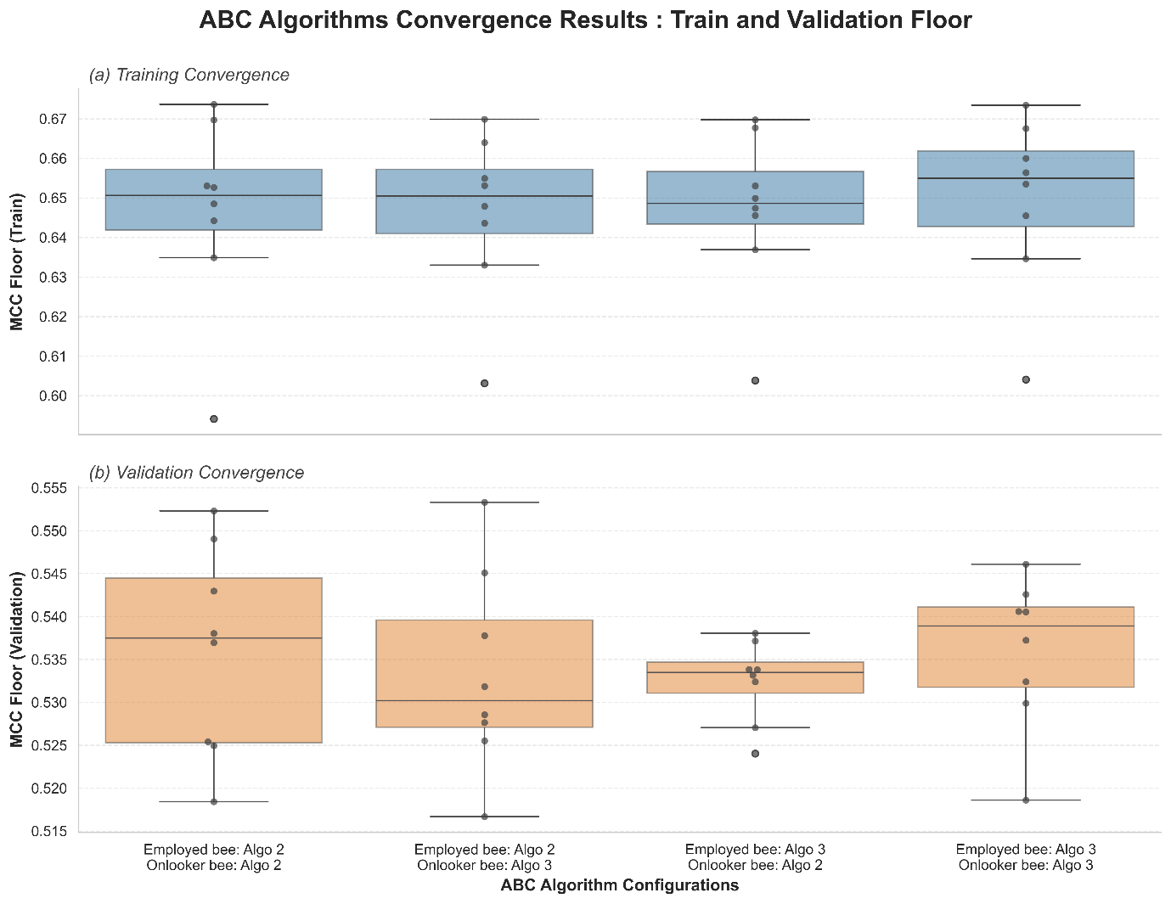
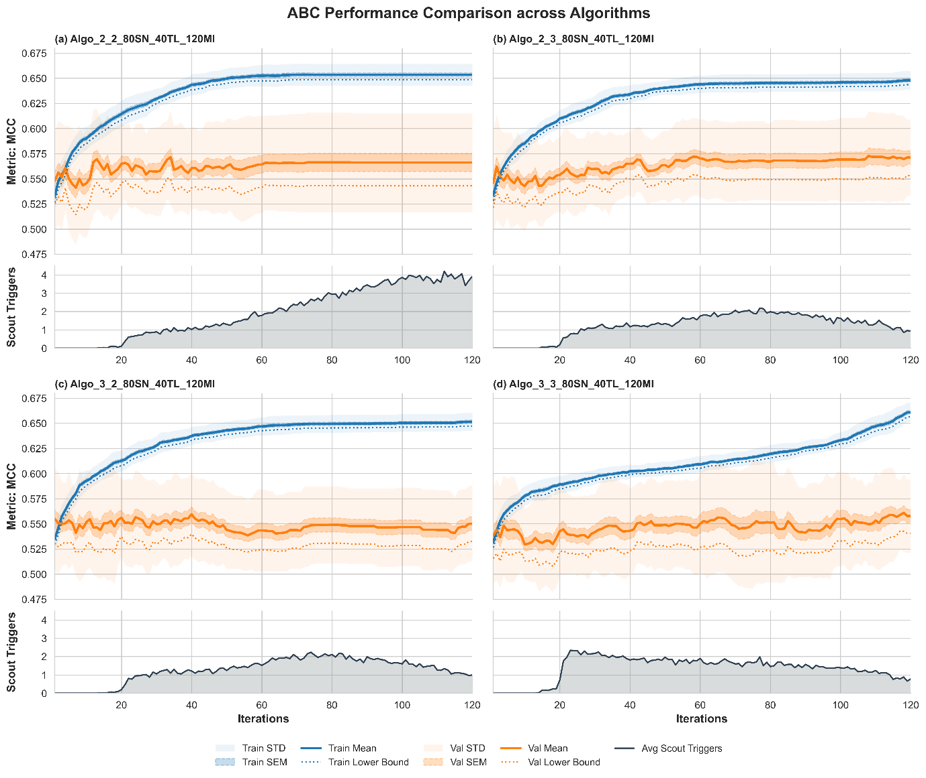

Trial Limit Ratio
Once internal algorithms were fixed, the trial limit ratio tracing was done across the same eight distinct configurations. According to the design of trail limit, the solution will at least be evaluated by one employed bee per iteration and probably evaluated by onlooker bee for variety times. For a high population ABC, the higher fitness solutions could be evaluated by onlooker bee high frequently, causing it easier to trigger the scout bee. Therefore, the number of $L$ was set to be a ratio connected with the population size $SN$ .
There were four different ratios were attempted, with table 2 and figure 3 showing that ratio of 1.5 outperformed others undoubtedly with a lowest obtained result still better than others median. AS ratio of 0.5 provided a lowest limit, which caused the bees had not enough time to exploit a solution properly, however it still gained the secondary performance which can be reasoned as effect of high-speed replacement of exhaustion solutions. In contrast, 2.0 provided too much limit which causing the bees wasted too much time on digging poor solutions performed the worst. Even 1.0 showing a smooth ratio of limit to population, the performance was not prominent as the benefits of high-speed replacement and deep exploitation had been neutralized. Comparably, the sweet plot ratio, 1.5 showing its outperformance over others, was selected as the $L/SN$ ratio.
$L/SN$ Ratio | Training ${ LCB}_{Model}^{\left(2\right)}$ | Validation ${ LCB}_{Model}^{\left(2\right)}$ | $${ LCB}_{L/SN}^{\left(3\right)}$$
0.5 | 0.6467 ± 0.0206 | 0.5324 ± 0.0047 | 0.5281
1.0 | 0.6511 ± 0.0208 | 0.5303 ± 0.0055 | 0.5252
1.5 | 0.6532 ± 0.0185 | 0.5406 ± 0.0060 | 0.5356
2.0 | 0.6543 ± 0.0190 | 0.5257 ± 0.0063 | 0.5199
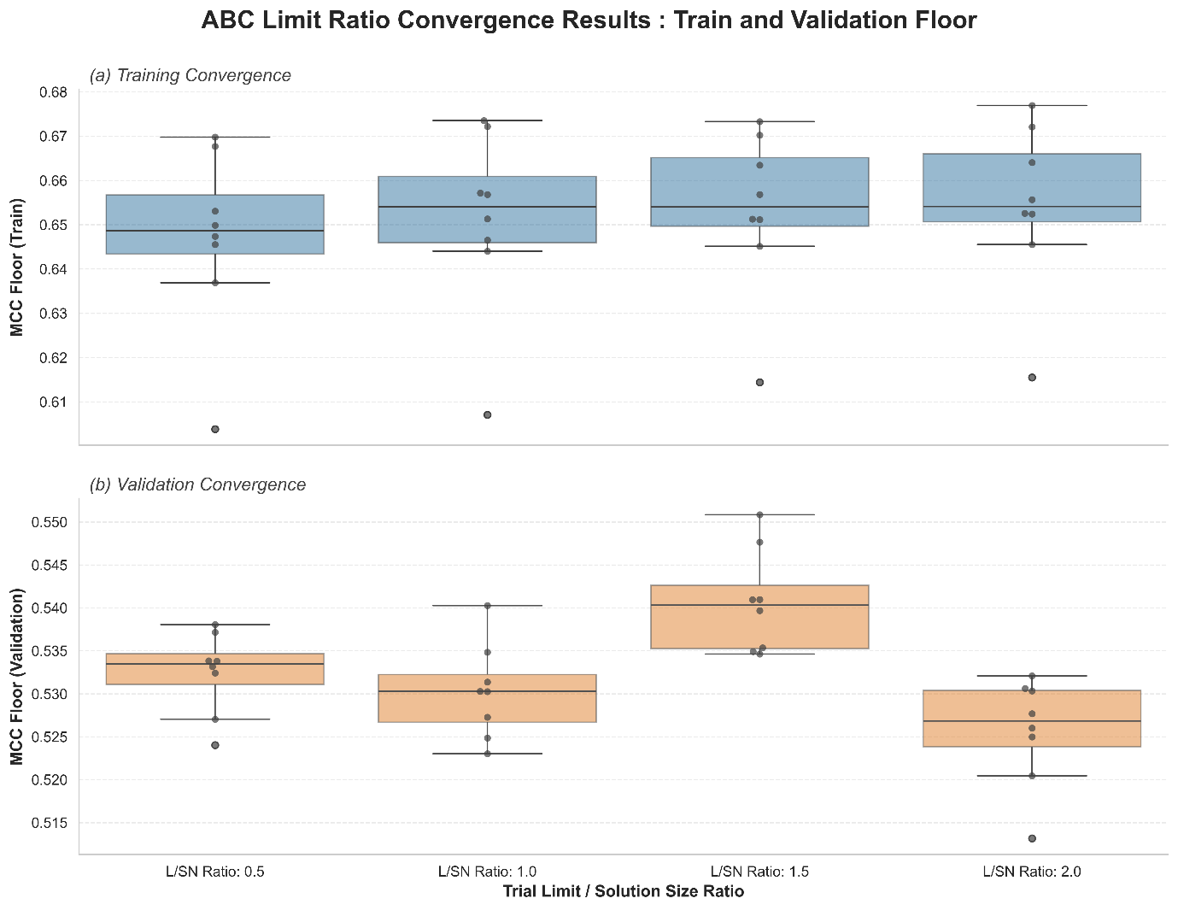

Populations and Iterations
Finally, with the onlooker bees applying algorithm 3 and employed bees applying algorithm 2, and the trial limit was set to $L=SN×1.5$ , the populations and iterations limit were trace over 36 group of the cross combination of $SN ∈\left\{10,20,50,80,100,250\right\}$ and $MI∈\left\{50,100,120,250,500,1000\right\}$. Figure 4a showed the heat map of convergence validation result ${ LCB}_{ABC ELM}^{\left(2\right)}$ of each combination of $SN$ and $MI$ , which defined the tracing of the parameter achieve the performance.
For the 10SN row and 50MI columns, the performances were generally lower due to narrowly search spaces and lack of iterations. In contrast, 250SN and 1000MI columns were also performed relatively weaker, this highlighted the enormous search populations or extreme search times having higher chance of overfitting. The 20SN with 250MI achieved the highest performance with 0.5508. However, 20SN achieved the worst and second worst performance with 50MI and 120MI respectively, suggesting that it was a non-stable solution sizes and the best performance was probably a sharp extreme peak value. While the area of 50-100 SN over 100-250MI performed a relatively high-average performance area, suggesting them as the area of relative plateau region.
Gaussian filter was applied to smooth the raw value with their surrounding value, which provided the more stable expected value of the parameters. The result was shown in Figure 4b. After the smoothing, the area of 50-100 SN over 100-250MI were still the relative plateau region, while 20SN with 250MI slide to third peak in the heatmap. The figure 5 showing the difference between the Gaussian smooth result and the raw result, the lower absolute value suggested that the more stable the parameters were. Consequently, 80SN and 120MI was selected as final parameter for the ABC algorithm.
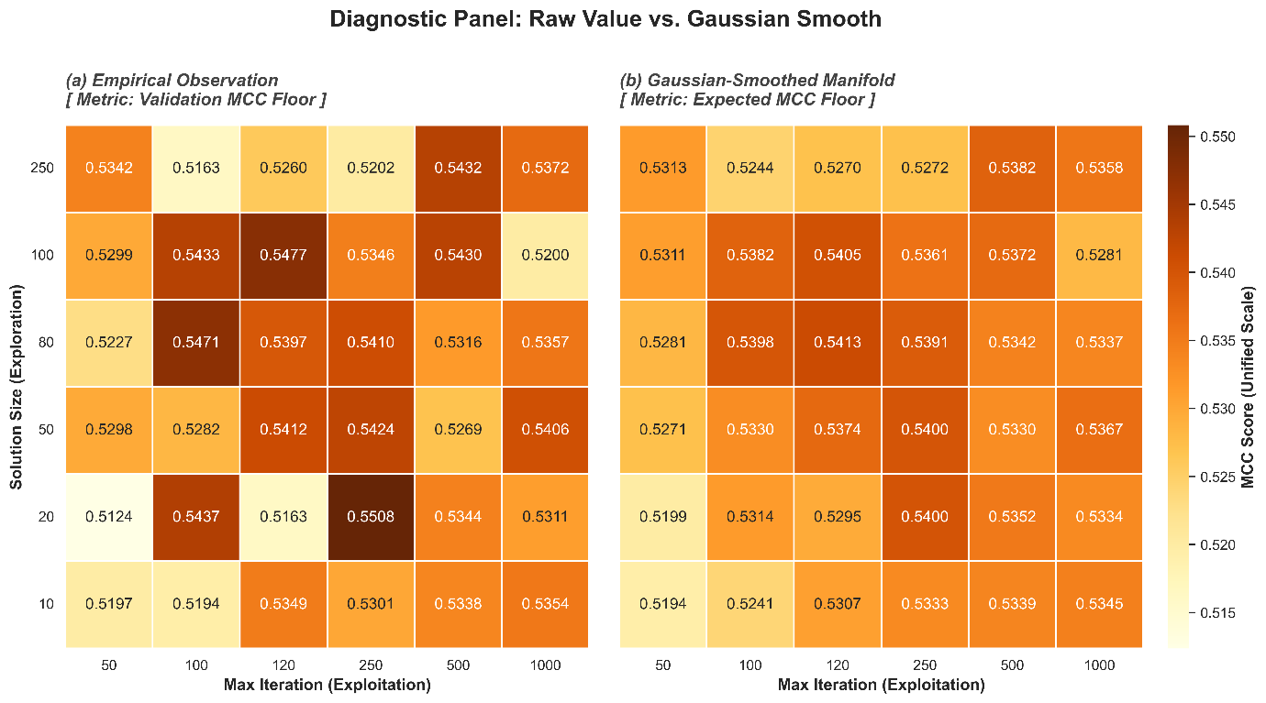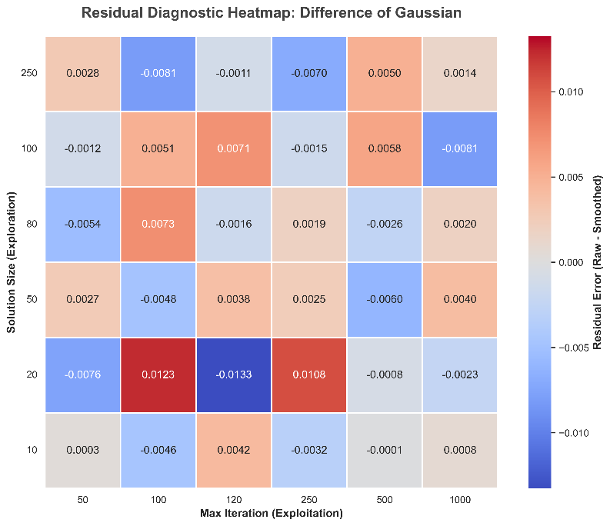

Result and Discussion
In the final test of 5-folds over 50 random seeds, ABC RELM CV achieved an average prediction score of 0.79 accuracy, 0.77 F1-Score and 0.60 MCC over the gallstone dataset.
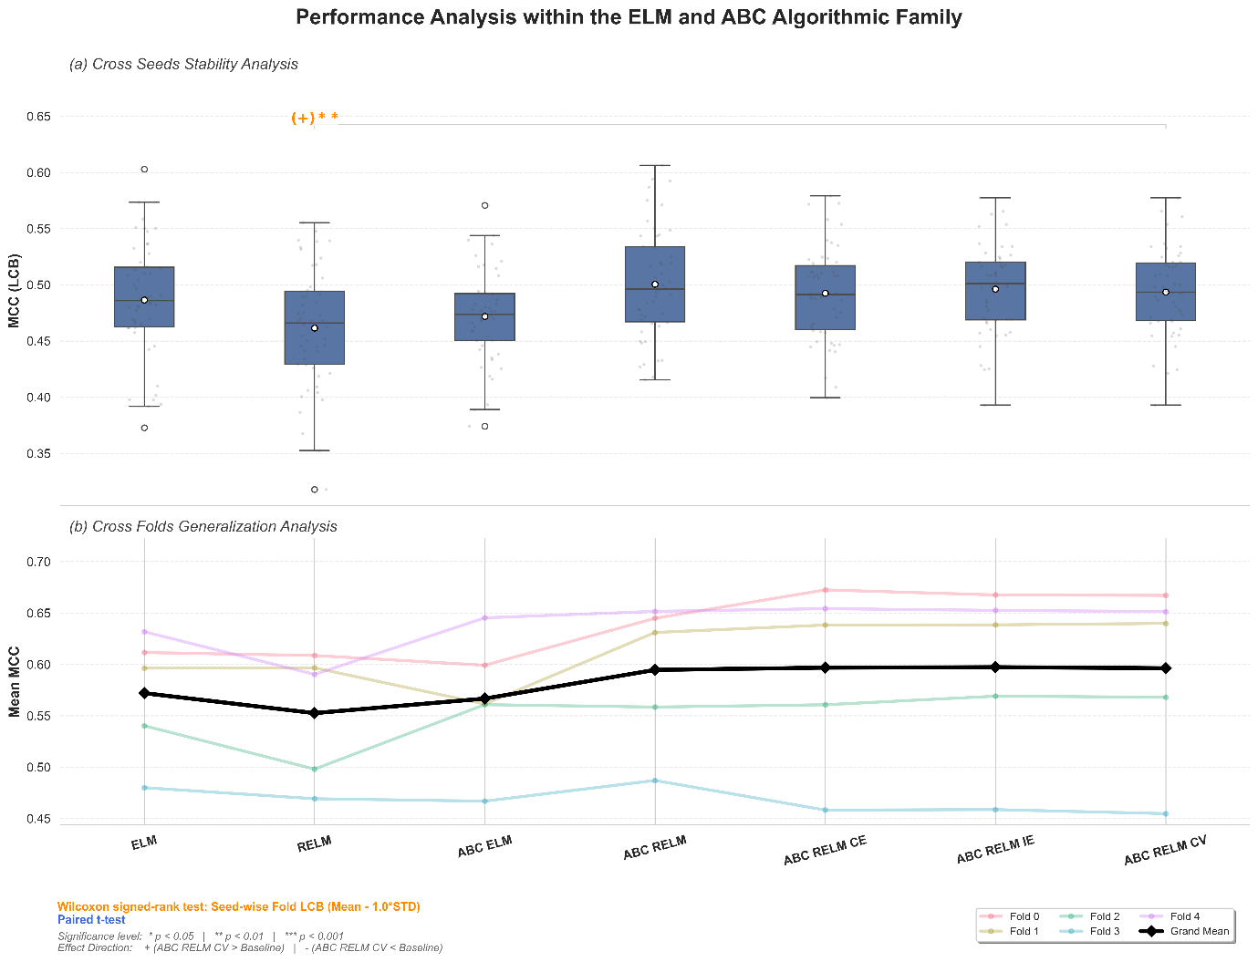
Model | Accuracy | F1-Score | MCC | P test | Direction
Stability (Metrics LCB with Wilcoxon signed-rank test)
ELM | 0.7396 ± 0.0246 | 0.7106 ± 0.0288 | 0.4864 ± 0.0504 | 1.0000 | 0
RELM | 0.7279 ± 0.0263 | 0.7013 ± 0.0316 | 0.4616 ± 0.0528 | 0.0059 | +1
ABC ELM | 0.7322 ± 0.0200 | 0.7011 ± 0.0246 | 0.4720 ± 0.0400 | 0.0593 | 0
ABC RELM | 0.7464 ± 0.0232 | 0.7178 ± 0.0244 | 0.5006 ± 0.0488 | 1.0000 | 0
ABC RELM CE | 0.7430 ± 0.0199 | 0.7165 ± 0.0215 | 0.4925 ± 0.0415 | 1.0000 | 0
ABC RELM IE | 0.7448 ± 0.0188 | 0.7177 ± 0.0204 | 0.4963 ± 0.0392 | 0.3958 | 0
ABC RELM CV | 0.7435 ± 0.0185 | 0.7164 ± 0.0206 | 0.4936 ± 0.0385 | - | -
Generalization (Metrics with paired t-test)
ELM | 0.7823 ± 0.0310 | 0.7612 ± 0.0365 | 0.5720 ± 0.0616 | 0.7757 | 0
RELM | 0.7733 ± 0.0317 | 0.7532 ± 0.0347 | 0.5525 ± 0.0641 | 0.2706 | 0
ABC ELM | 0.7800 ± 0.0335 | 0.7585 ± 0.0411 | 0.5667 ± 0.0657 | 0.7757 | 0
ABC RELM | 0.7934 ± 0.0355 | 0.7723 ± 0.0417 | 0.5946 ± 0.0707 | 1.0000 | 0
ABC RELM CE | 0.7945 ± 0.0437 | 0.7741 ± 0.0484 | 0.5967 ± 0.0884 | 1.0000 | 0
ABC RELM IE | 0.7949 ± 0.0426 | 0.7745 ± 0.0476 | 0.5972 ± 0.0862 | 0.8750 | 0
ABC RELM CV | 0.7943 ± 0.0433 | 0.7739 ± 0.0483 | 0.5962 ± 0.0877 | - | -

Table 3 and figure 6 were the first phase evaluation of the ABC RELM CV, which compared to the within-family models. As mentioned before, the stability of models was traced on its MCC pessimistic floor ${ LCB}_{r}^{\left(1\right)}$ , which calculated the risk averse score of 5 folds results, while the generalization ability was evaluated based on 50 seeds average results.
ABC RELM CV outperformed RELM was statistically, which suggested that the optimization process was successful increase the stability of random initialization’s ${ LCB}_{r}^{\left(1\right)}$. Besides that, ABC RELM CV obtained a marginal significance well performance compared to ABC ELM, which denoted that it was almost guaranteed to be better than it. However, ELM showing a better result compared to RELM and ABC ELM even not significance, indicated that the parameter tuning process could probably systematic overfit to the validation set. Fortunately, the standard deviation of the ${ LCB}_{r}^{\left(1\right)}$ of ABC ELM still performing tighter than ELM, denoted that the ABC optimization was still work.
In contrast, during the evaluation of model generalization ability, there was not any significance outperforming. In this case, ELM was performed slightly better than RELM and ABC ELM, while holding a lowest variance across 5 folds of data. RELM could be lose to ELM due to the lower number of hidden nodes even the architecture outperformed during validation stage. ABC ELM performance lightly weaker could be reasoned by unfit parameter for ABC algorithm used as the parameter were tuned over RELM. Comparably, there was an obvious difference ABC RELM CV lineage with the others. They achieved the better result in fold 0 and fold 1, similar result in fold 2 and fold 4, yet obtained worst result in fold 3. This suggested that the fold 0 and fold 1 data characteristic were successfully extract by internal cross validation fitness of ABC RELM CV. However, the fold 3 performance was decrease by this architecture, which might be due to the abnormally of characteristic of the split of data in fold 3.
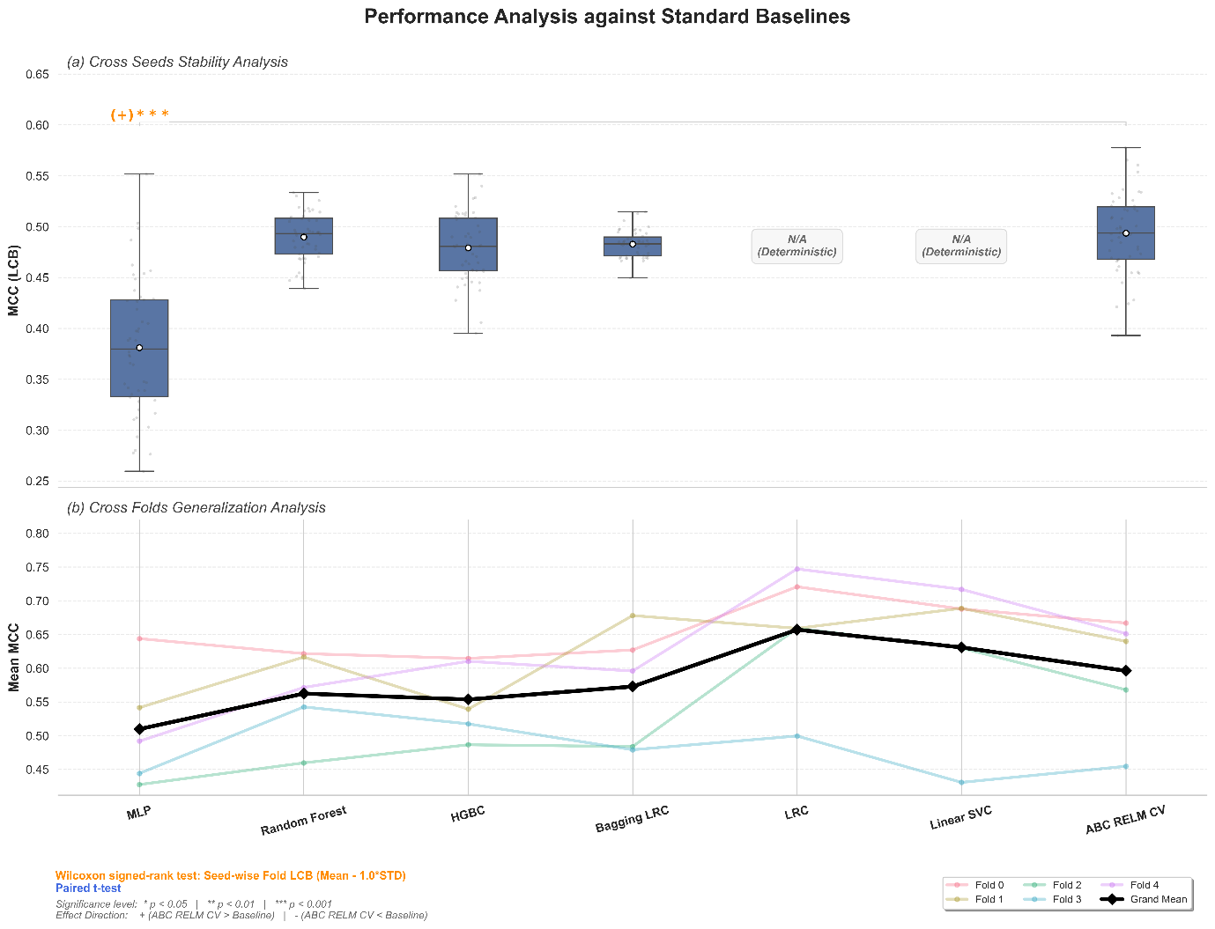
Model | Accuracy | F1-Score | MCC | P test | Direction
Stability (Metrics LCB with Wilcoxon signed-rank test)
MLP | 0.6826 ± 0.0351 | 0.6719 ± 0.0469 | 0.3811 ± 0.0657 | $$1.5445×{10}^{-11}$$ | +1
Random Forest | 0.7446 ± 0.0115 | 0.7378 ± 0.0117 | 0.4899 ± 0.0231 | 0.5852 | 0
HGBC | 0.7382 ± 0.0164 | 0.7245 ± 0.0182 | 0.4790 ± 0.0332 | 0.15897 | 0
Bagging LRC | 0.7405 ± 0.0065 | 0.7249 ± 0.0079 | 0.4829 ± 0.0128 | 0.17159 | 0
LRC | 0.7776 ± 0.0000 | 0.7546 ± 0.0000 | 0.5610 ± 0.0000 | - | -
Linear SVC | 0.7560 ± 0.0000 | 0.7366 ± 0.0000 | 0.5146 ± 0.0000 | - | -
ABC RELM CV | 0.7435 ± 0.0185 | 0.7164 ± 0.0206 | 0.4936 ± 0.0385 | - | -
Generalization (Metrics with paired t-test)
MLP | 0.7487 ± 0.0442 | 0.7394 ± 0.0420 | 0.5098 ± 0.0872 | 0.2281 | 0
Random Forest | 0.7804 ± 0.0326 | 0.7707 ± 0.0289 | 0.5625 ± 0.0661 | 0.7478 | 0
HGBC | 0.7756 ± 0.0286 | 0.7635 ± 0.0287 | 0.5537 ± 0.0569 | 0.6247 | 0
Bagging LRC | 0.7855 ± 0.0443 | 0.7732 ± 0.0473 | 0.5729 ± 0.0884 | 0.7478 | 0
LRC | 0.8269 ± 0.0493 | 0.8136 ± 0.0589 | 0.6572 ± 0.0962 | 0.0807 | 0
Linear SVC | 0.8143 ± 0.0583 | 0.8018 ± 0.0652 | 0.6309 ± 0.1163 | 0.4204 | 0
ABC RELM CV | 0.7943 ± 0.0433 | 0.7739 ± 0.0483 | 0.5962 ± 0.0877 | - | -

Table 4 and figure 7 presented the second phase evaluation of the ABC RELM CV, which compared to the scikit learn baseline models. The model outperformed the MLP significantly in stability. The result could be reasoned by the insufficient dataset size for complicate back propagation of MLP model, causing the training to be underfit or overfit. The ABC RELM CV stability score ${ LCB}_{r}^{\left(1\right)}$ performed slightly weaker than RF, while slightly better than Bagging LRC and HGBC. However, the Bagging LRC showing the most stable performance over all other models beside the excluded convex optimization models, highly because it is a convex optimization model in root above the bagging strategy.
During the evaluation of generalization ability of models, although there was not any statistical significance, LRC and Linear SVC were outperforming others. LRC and Linear SVC achieved better results in all folds other than fold 3, this suggests that the data set was higher linear separately than high dimensionally. Besides that, the worst-case fold 3 for most models performed better in RF and HGBC, evidenced that the fold splitting contained of data which having Mathematics inconsistency but characteristic representative. Excluding the linear models, ABC RELM CV obtained the best performance over the baselines, highly due to the ELM output weights determination was also a convex optimal if the hidden output was fixed. This indicated that the gallstone dataset utilized was a highly linear separately, and most high dimensional calculation brought to overfit the noise.

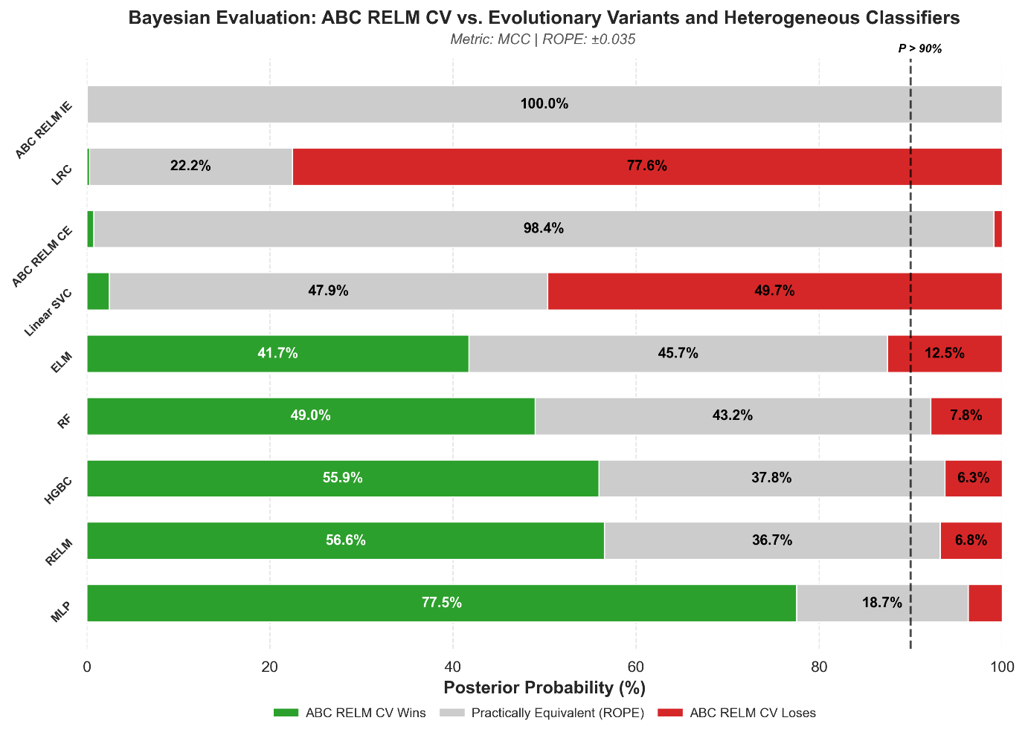
Model | Accuracy | F1-Score | MCC | P Win
ABC RELM CV | 0.7943 ± 0.0433 | 0.7739 ± 0.0483 | 0.5962 ± 0.0877 | -
ABC RELM IE | 0.7949 ± 0.0426 | 0.7745 ± 0.0476 | 0.5972 ± 0.0862 | 0.0000
LRC | 0.8269 ± 0.0493 | 0.8136 ± 0.0589 | 0.6572 ± 0.0962 | 0.0027
ABC RELM CE | 0.7945 ± 0.0437 | 0.7741 ± 0.0484 | 0.5967 ± 0.0884 | 0.0074
Linear SVC | 0.8143 ± 0.0583 | 0.8018 ± 0.0652 | 0.6309 ± 0.1163 | 0.0245
ELM | 0.7823 ± 0.0310 | 0.7612 ± 0.0365 | 0.5720 ± 0.0616 | 0.4173
RF | 0.7804 ± 0.0326 | 0.7707 ± 0.0289 | 0.5625 ± 0.0661 | 0.4895
HGBC | 0.7756 ± 0.0286 | 0.7635 ± 0.0287 | 0.5537 ± 0.0569 | 0.5593
RELM | 0.7733 ± 0.0317 | 0.7532 ± 0.0347 | 0.5525 ± 0.0641 | 0.5655
MLP | 0.7487 ± 0.0442 | 0.7394 ± 0.0420 | 0.5098 ± 0.0872 | 0.7753

Finally, the representative models were included in the Bayesian evaluation to obtain the quantifying perspective of the probabilistic of outperforming. The region of practical equivalence was set to be 0.035 by calculating the changes of one classification difference over average 64 tested samples. The models were classified into several groups for better observation: base models (ELM, RELM), variant models (ABC RELM CE, ABC RELM IE), SLFNs model (MLP), tree models (RF, HGBC) and linear models (LRC and Linear SVC).
Even though the first phase comparison showed a close performance between ABC RELM CV and the base type, the Bayesian evaluation posterior probability showed that there was more than 40% ABC RELM CV would be outperforming and only less than 15% chance of losing. Differently, there were more than 98% the ensemble variants achieved rope, evidenced that the internal ensemble was not able to produce the variety requirements of ensemble theory. The usage of the same solutions within internal cross-validation or the picking of different iteration solutions based on cosine similarity was inappropriate.
Furthermore, ABC RELM CV obtained nearly 50% of winning with less than 10% of losing comparing to the tree models and achieved more than 75% of winning rate in the comparison with MLP. Conversely, during the comparison with linear models, ABC RELM CV showed no more than 10% of winning chance, with more than 75% lose to LRC and nearly 50% lose to linear SVC. The performance of linear models had dominated across this dataset. Although unable to outperform the linear models, ABC RELM CV had high chance to perform better than the remain models, suggesting that it was still achieving a relatively good result.

Appendix

Baseline Models

Logistic Regression Classifier (LRC)
Logistic Regression is a simple and widely used classification model. It combines input features linearly and applies a sigmoid function to map the output into a probability between 0 and 1. The model is typically trained using Maximum Likelihood Estimation (MLE), allowing it to learn the parameters that best fit the data.

Linear Support Vector Classification (Linear SVC)
Linear Support Vector Classification (Linear SVC) is a supervised learning model used for classification tasks. It works by finding a linear hyperplane that separates different classes while maximizing the margin between them. Unlike kernel-based SVC, Linear SVC does not map data into higher-dimensional space, making it more efficient for linearly separable or high-dimensional datasets. It also includes regularization and soft-margin mechanisms to handle noise and improve generalization.

Multi-Layer Perceptron (MLP)
A Multilayer Perceptron (MLP) is a type of feedforward neural network made up of an input layer, one or more hidden layers, and an output layer. It learns by applying linear transformations followed by non-linear activation functions (such as ReLU), allowing it to model complex relationships in the data. The model is trained using backpropagation to minimize a loss function (commonly cross-entropy), with optimization methods like gradient descent or Adam used to update the weights.

Random Forest (RF)
Random Forest is an ensemble learning method that builds multiple decision trees using different subsets of the training data. Each tree is trained on a bootstrap sample, and at each split, a random subset of features is considered to increase diversity among the trees. The final prediction is made by combining the outputs of all trees, typically through majority voting. This approach helps reduce overfitting and improves overall model stability and accuracy.

Hist Gradient Boosting Classifier (HGBC)
Histogram-based Gradient Boosting Classifier (HGBC) is an efficient implementation of gradient boosting using decision trees. It builds models sequentially, where each new tree is trained to correct the errors made by the previous ones. To speed up training, it groups continuous features into discrete bins (histograms), which reduces the cost of finding optimal split points. This makes HGBC faster and more scalable while still maintaining strong predictive performance.

Bagging Logistic Regression Classifier (Bagging LRC)
This approach is an ensemble method that applies bootstrap aggregating (bagging) to Logistic Regression models. It creates multiple subsets of the training data through sampling with replacement and trains a separate Logistic Regression model on each subset. The final prediction is obtained by combining their outputs, which helps reduce variance and improve stability. This allows the model to achieve better performance while maintaining the simplicity and interpretability of linear models.

The candidate solutions were split into 3 group by 33% interval of iteration number and 2 groups by half iteration differently. Ensemble of 5 models will be produced if the conditions were met: total solution size \geq11 , last third solutions having size \geq3 and the middle third solutions having size \geq2 . Total two candidates were pick from last third solutions and one candidate from each middle third and first third solutions to form the models. If the condition didn’t be met, it will try to build a 3-model ensemble, which considered the condition: total solution size \geq7 and last half solutions having size \geq2 . Total one candidate was picked from each half groups. The model will fall back to simple ABC ELM CV if the above conditions are both fail.

